**Test report - Deployment of Arktos Cluster with Mizar CNI on GCE**

This document captures the steps to deploy an Arktos cluster lab with mizar cni. The machine in this lab used are GCE e2-standard-8 (8 vCPUs, 32 GB memory) and the storage size is 128GB), Ubuntu 18.04 LTS.

Date-21.12.2021

# Create an instance on GCE

Created instance on GCE



# Step-1: Update kernel (If required)

To check kernel, run following command

uname -a

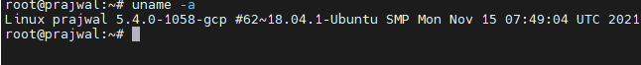

Here kernel version is 5.4.0-1051-gcp which is less than the required kernel version, so to update the kernel version to 5.6.0-rc2, we used the following steps :

|  |  |
| --- | --- |
| wget https://raw.githubusercontent.com/CentaurusInfra/mizar/dev-next/kernelupdate.sh | |
| sudo bash kernelupdate.sh |  |

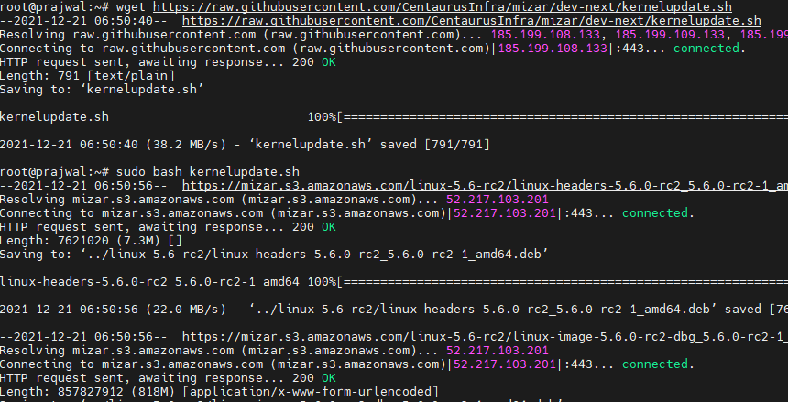

# Step-2: Install dependencies

Relogin and Run the following steps to install dependencies required for arktos deployment:

mkdir -p $GOPATH/src/github.com

cd $GOPATH/src/github.com

git clone <https://github.com/CentaurusInfra/arktos>

cd arktos

sudo bash hack/setup-dev-node.sh

export PATH=$PATH:/usr/local/go/bin

make

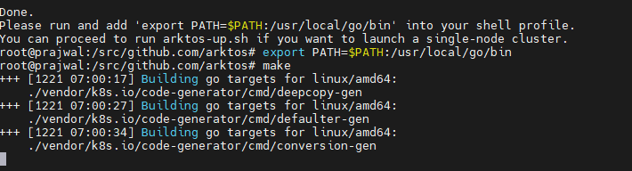

# Step-3: Start Arktos cluster

Run following step to deploy arktos cluster with Mizar as CNI:

CNIPLUGIN=mizar ./hack/arktos-up.sh

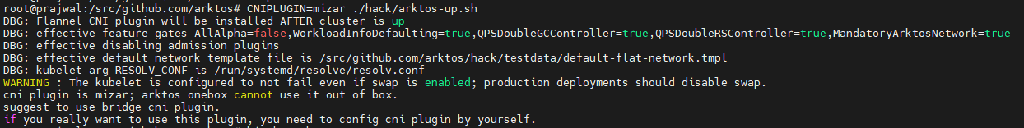

ERROR**: Arktos onebox cannot use it out of box.**